WATER RESOURCES COMMITTEE
AGENDA
TUESDAY, 17 NOVEMBER 2015 7:30 PM
TOWN HALL – DPW OFFICE
Item | Topic | Discussion Leader
1. | Call to Order | John Clarkeson
2. | Review of Agenda | John Clarkeson
3. | Acceptance of Meeting Minutes: March, October | John Clarkeson
4. | Status of Water Resources: Water System Update | James DeBarros
New Business
5. | Community Preservation Committee:  Review of relevant applications | John Clarkeson
Old Business - Updates
6. | Water Conservation Plan – Other board reviews
 | Economic Development | John Clarkeson
 | Board of Health | Martha Cook
 | Planning Board | Becky Malamut
 | Conservation Commission | Shirley Young
 | NSRWA
7. | Board of Health Regulations RE: Private Wells | Martha Cook
8. | Education Outreach - Scituate Schools | Martha Cook
Other

9. | Recent Correspondence
9. | Open Discussion | Committee
10. | Adjournment

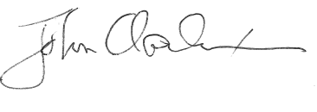

_____________________
John Clarkeson, Chairman

