WATER RESOURCES COMMITTEE
AGENDA
TUESDAY, 27 OCTOBER 2015 7:30 PM
TOWN HALL – DPW OFFICE
Item | Topic | Discussion Leader
1. | Call to Order | John Clarkeson
2. | Review of Agenda | John Clarkeson
3. | Acceptance of Meeting Minutes | John Clarkeson
4. | Status of Water Resources: Water System Update | James DeBarros
New Business
5. | Community Preservation Application: Maxwell Land Trust | Cynde Robbins
6. | Recent correspondence | John Clarkeson
Old Business - Updates

7. | Board of Health Regulations RE: Private Wells | Becky Malamut
8. | Water Conservation Plan | Becky Malamut
Other

9. | Open Discussion | Committee
10. | Adjournment
The Water Resources Committee reserves the right to alter the order in which items will be discussed
during the meeting.

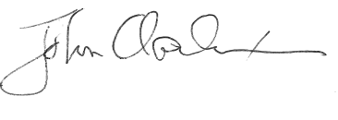

_____________________
John Clarkeson, Chairman

