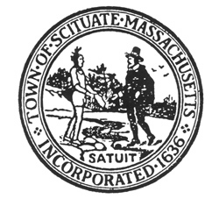
Scituate Accessibility Awareness Event
Saturday, November 3, 2018
11am-2pm, Open House
Scituate Community Building (formerly Pier 44) Jericho Rd, Scituate

To all area residents, including caregivers, friends, and families!
Celebrate Differences and learn about Accessible Services & Resources!

C.O.R.S.E. Foundation  (Community of Resources  For Special Education) | Scituate Coastal Coalition
Friendship Home | Scituate Council on Aging
GATRA (Greater Attleboro Taunton  Regional Transit Authority) | Scituate Etrusco Associates (loans of durable Medical Equipment
Independence Associates | Scituate Fire & Police Departments
INDEX, Shriver Center, UMass Medical School | Scituate Housing Authority
MA Commission For The Blind | Scituate Special Education Department
MA Commission For The Deaf | Scituate Recreation Department
MA Department of Conservation & Recreation-  Universal Access Program | Scituate Town Nurse * (flu shots will be available as supplies last)
MA Equipment Distribution Program | Scituate Town Library
MA Office on Disabilities | South Shore ARC (Autism Resource Center)
MA Rehabilitation Commission | South Shore Elder Services
National Multiple Sclerosis Society | South Shore Peer Recovery
Perkins School for the Blind | Talking Book Library for the Blind
Road to Responsibility | Talking Information Center
SAFE Allergy Group | Wellspring

Artwork created by Scituate Recreation summer students celebrating our differences will be on display!

Refreshments and fun activities for kids, including face painting, music, arts and crafts will be provided by our Scituate Hugh School students.

*This is a scent free event!

Organized by the Scituate Commission on Disabilities

