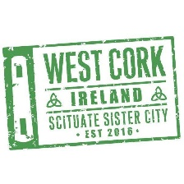
Scituate /West Cork Sister City Committee
Mission Statement
The Mission of the Scituate/West Cork Sister City Committee is to promote partnerships; foster an understanding of cultures and traditions; facilitate exchange programs for students and adults; encourage tourism; share advances in business and education; and provide activities that will be of mutual benefit to Scituate and West Cork.

Agenda
June 14th 5 pm
Scituate Senior Center

The Scituate West Cork Sister City is committed to providing an environment of respect during meetings. We ask all members to interact in a polite manner even when there is disagreement. We value the participation of our community and want all participants, including marginalized and minoritized communities, to feel welcomed and respected. We ask our committee members, and all who participate, to commit to these standards to support and respect our community.

Scheduled Items:

- Acceptance of Agenda
- Acceptance of Minutes
- Treasurers Report
- Sister City Calendar Fundraiser
- Student Exchange
- Appointments
- New Business

Next Meeting TBD

