WATER RESOURCES COMMITTEE
AGENDA
TUESDAY, 27 september 2016 7:30 PM
TOWN HALL – DPW OFFICE

Item | Topic | Discussion Leader
1. | Call to Order | John Clarkeson
2. | Review of Agenda | John Clarkeson
3. | Acceptance of Meeting Minutes | John Clarkeson
4. | Water System Update
Old Business - Updates
5. | Water Conservation Measures – Drought Response
6. | Meters Policy
New Business
7. | Communnity Preservation Grant Applications | Peter Detwiler
8. | Recent Correspondence | Committee
9. | Open Discussion | Committee
10. | Adjournment

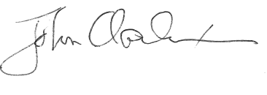

_____________________
John Clarkeson, Chairman

