WATER RESOURCES COMMITTEE
AGENDA
TUESDAY, 15 NOVember 2016 7:30 PM
TOWN HALL – DPW OFFICE

Item | Topic | Discussion Leader
1. | Call to Order | John Clarkeson
2. | Review of Agenda | John Clarkeson
3. | Acceptance of Meeting Minutes | John Clarkeson
4. | Water System Update
Old Business - Updates
5. | Water Conservation Measures – Drought Response
6. | Meters Policy – Final Discussion and Vote
New Business
7. | Recent Correspondence | Committee
8. | Open Discussion | Committee
9. | Adjournment

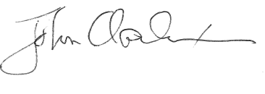

_____________________
John Clarkeson, Chairman

