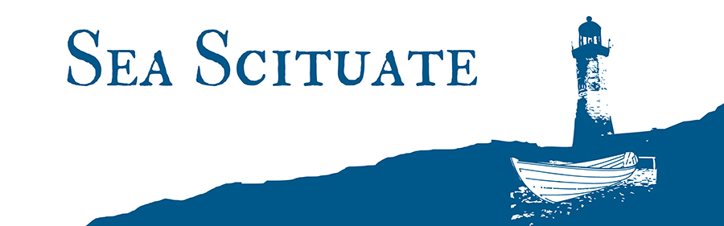

Town of Scituate, Massachusetts
Economic Development Commission Meeting
Wednesday November 9, 2016 - 7 PM

The WPA Building, 7 Henry Turner Bailey Rd.

Agenda

- The Scituate Brewery – Status on DPW issues discussed with John Danehey during our September meeting.

- The Scituate Beach Commission –“Sea Scituate” - refurbishing & branding the town’s beach trash barrels.

- The Massachusetts Cultural Facilities Fund – Cole Parkway Bandstand

- The Greenbush Vision Plan - Work session to build and publish a calendar of what needs to be accomplished over the next 12-15 months to drive the Greenbush Vision plan. Also, update on 9/22 -Planning Board presentation.

- Scituate Way-Finding signage – Proposed initial signage locations presented to the BOS at their10/4 meeting. Next steps.

- The 2017 New England Boat Show – EDC’s sponsorship role.

Approve the minutes for the September 21, 2016 EDC meeting.
There was no October meeting of the Economic Development Commission.
The EDC will meet next on Wednesday December 14, at the WPA building.

Submitted by Monte Newman, Secretary.

