TOWN OF SCITUATE
www.scituatema.gov

600 Chief Justice Cushing Highway Scituate, Massachusetts 02066
Fax (781) 545-8704

Scituate Commission on Disabilities
Agenda 6/14/2017
7:30 PM Scituate Public Safety Building
Call in Number 781-544-7951

1. Call to Order.
- Acceptance of Past Minutes.
- Old Business:
- Monitoring
  - Jenkins School Curb Cut and path.
  - New Middle School Building and New Safety Building Plans.
  - Shared Concerns with Harbormaster Steven Mone. Parking/Entrance Way/Accessibility of Structures/etc. TRRA meetings Parking/Fines/Dispatch/Enhanced 911/etc. Locating All of the Town of Scituate, Massachusetts Handicap Parking Spaces
  - The Setup and Plans for New and all Playgrounds
  - Country way – Tilden Road Trail Plans
  - Town .of Scituate, Massachusetts' "TRANSITION PLAN."
  - Council on Aging Update
- Broadening Transportation for the Disabled and/or Their children/dependents.
  - GATRA expansion for summer program and early 2017-2018 school year
- Sea Walls /Beach Entrance Ways
- Follow up on Art Project on MOD website
- Blueprint review for Country Way
- Hosting a Forum
- Revised assessment form for accessibility and functional status
- New Business:
  - Independent Living Center representatives
  - Guests from the Police Department
  - Upcoming Training and Seminars
- Potential Past and new ADA Violations
- Chairperson's Comments.
- Adjournment.

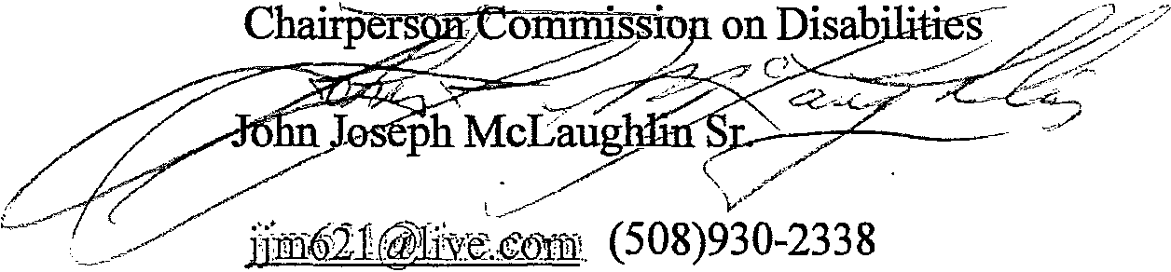
Our Next Meeting is Wednesday July 12, 2017 at 7:30 at Selectmen’s Hearing Room

