WATER RESOURCES COMMITTEE
AGENDA
TUESDAY, 31 JANUARY 2017
7:30 PM
TOWN HALL – DPW OFFICE
Item | Topic | Discussion Leader
1. | Call to Order | John Clarkeson
2. | Water System Update
3. | Private Wells / Board of Health
4. | 2017: Issue Planning
 | Private Wells
 | Meter Policy
 | Reservoir Sustainability
 | Water Conservation – Proactive Measures
 | Plan recommendations
5. | North and South River Watershed Association | Samantha Woods  Sarah Grady
6. | Recent Correspondence | Committee
7. | Open Discussion | Committee
8. | Adjournment
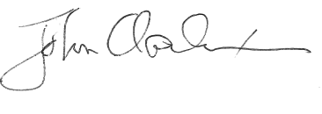

_____________________
John Clarkeson, Chairman

Proposed meeting schedule 2017 – Last Tuesday of each month

January 31 | July 25
February 28 | August 29
March 28 | September 26
April 25 | October 26
May 30 | November 28
June 27 | December – no meeting

