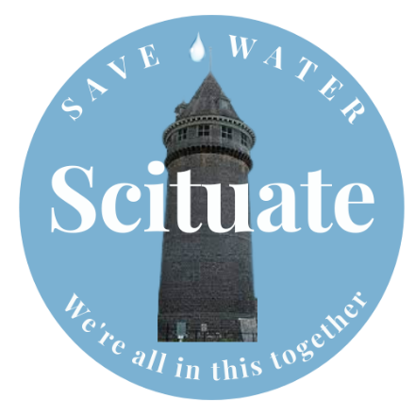
WATER RESOURCES COMMISSION MEETING MINUTES

Location: Town Hall, DPW office
Date: October 17, 2023, 6:30 PM

Call to order
Members present:
- Bruce Arbonies, Chair
- Emily Simmer, Secretary
- Kristen Jamski
- Freya Schlegel
- Peter Weafer
- Joanne Wyckoff

Members absent:
- Jacqueline Bohn

Others present:
Bob Delorenzo, head of newly formed Desalination Subcommittee
Kevin Cafferty, Scituate DPW Director

- Call to order

- Water System Updates
Reservoir is full. Staffing down one operator – still trying to fill vacant positions. DPW staffing is down across the department.
  - Brown Water update
Well 17 has been shut down to rest for a while, in part due to it producing discolored water. The engineers are continuing to investigate the cause and potential solutions. Could in part be due to our heavy reliance on this well.
  - New Water Treatment Plant Update
Work is still on schedule, working on permitting, etc. Design about 60% done. They need to put a wall around the septic system which has created a variance request.
  - Reservoir Dam Repair and Expansion Project
Tom Cook is away but they will meet with him in late Oct or early Nov.

- Desalination Subcommittee Update
Dighton has been unresponsive to our requests to visit/tour. It’s a backup water source for Brockton so it isn’t in heavy use. By state law they are required to have a second water source so the desal plant serves that purpose, though they don’t operate it more than they have to. Bob met with the Army Corp of Engineers about the permitting process for desal. Desal projects using renewable energy are much more favorably viewed because the process is so energy intensive. They want to know how much $ we spend currently for our water and that is a tough figure to calculate. Wells are the cheapest way to get water by far because that water gets naturally filtered in the earth – the deeper the better. We might need to start with an environmental impact study looking at different, locations, sizes, impacts, etc.

The Army Corps recommended we look into gray water systems as they consider that a more efficient water treatment over desal. Freya shared that when she researched this option last year she learned it was tough to do in colder climates because you need to keep the lines from freezing. Desalination companies may be willing to fund a study, which would likely cost about $250,000. Tampa’s desal plant is having issues where water is too salty, which is another challenge we need to consider.

Oneika Technologies in Canada makes small units built from recycled plastic that filter the water using reverse osmosis. In this process, the discharge is only 50% saltier not 100%, and they can get 13,000 gallons a day but they only use for emergencies. It uses the energy of the waves so the energy and impact is less. Bruce/Bob will reach out to MIT. And may be time to reach out to TA and SB to get their input on next steps – are we ready to do an env impact study, and if not what do we need to do before then? Kevin recommended reaching out to Umass Lowell as they have a great water treatment system and get hit up less frequently than MIT. Freya, Bob, and Bruce will meet to nail down next steps.

- Debrief of September 19th Public Education Meeting
  - What went right/wrong?
  - How to improve for next year?
We discussed whether an annual forum is the best way to communicate with the public, or should we consider having more frequent public forums, maybe 4x/year. Would this be a good use of our time considering attendance has dwindled? We only had ~15 members of the public this year – apparently several people weren’t able to get through the security block but it is hard to know how many. We discussed the merits of these meetings v making videos, encouraging attendance at our current meetings. Joanne says ConCom meetings are very well attended. Discussed Emily and Freya to work together on a public ed subcommittee and connect with Seth about doing some Q and A videos with Kevin. Construction for new WTP starts in may – Kristen suggested maybe tying our outreach it to that. Bruce mentioned videoing pipe flushing and other maintenance work. Communication is an ongoing conversation.

- 2024 Planning Discussion
Bruce circulated the working doc we’ve had going regarding our priorities. So far priorities have been our annual rain barrel sale and public info forum. We will definitely sell rain barrels again this spring and will do some form of public outreach / communication even if it takes a different form than in the past. We would like to work to improve communication about town and conservation measures, and support the town with messaging – communicating about rain barrels, water ban, ban tiers if they change, WTP, etc. Apparently the DPW staff are loving using the rain catchment water to wash their trucks – another idea for a video. Emily offered to draft a calendar showing our annual priorities and timeline that we can use as a template and update from year to year. Rebate program requests are still coming in – we can help town with continued communications about that program.

- Liaison Updates
  - BOH – Jackie not here, no updates
  - Planning board – Freya – they are very busy working on the MBTA community compliance mandate (increasing # of units walkable to train stops)
  - Zoning – Bruce – 1 item in water protection district but no issues. Next meeting this Thursday.
  - Joanne – Con Com – no update
  - SBC – Pete – sustainability subcommittee has formed and they had a meeting about LEED certification
  - Kristen – had no liaison position but agreed to take on EDC going forward

- Approve August minutes
Joanne moves to approve minutes – approved unanimously
- Open Discussion
None

- Adjourn

